NAME:M.srivardhan
REG NO:192425208 CSA0318 - LAB EXPERIMENTS
EX.NO:28 REVERSING A 32 BIT SIGNED INTEGERS
#include <stdio.h>
#include <limits.h>
int main() {
int n, rev = 0, digit;
printf("Enter a 32-bit signed integer: ");
scanf("%d", &n);
while (n != 0) {
digit = n % 10;
n = n / 10;
if (rev > INT_MAX / 10 || rev < INT_MIN / 10) {
printf("Overflow occurred! Cannot reverse.\n");
return 0;
}
rev = rev * 10 + digit;
}
printf("Reversed Integer = %d\n", rev);
return 0;
}

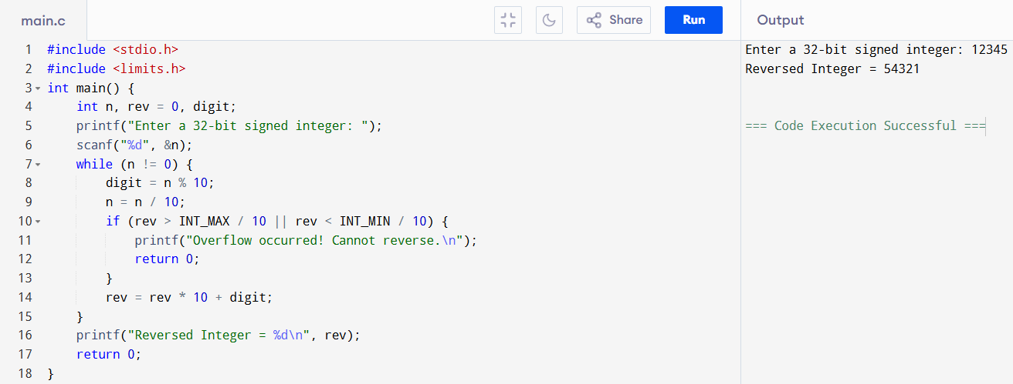
EX.NO:29 TO CHECK FOR A VALID STRING
#include <stdio.h>
#include <ctype.h>
int main() {
char str[100];
int i, valid = 1;
printf("Enter a string: ");
gets(str);
for(i = 0; str[i] != '\0'; i++) {
if(!isalnum(str[i])) {
valid = 0;
break;
}
}
if(valid)
printf("Valid String\n");
else
printf("Invalid String\n");
return 0;
}

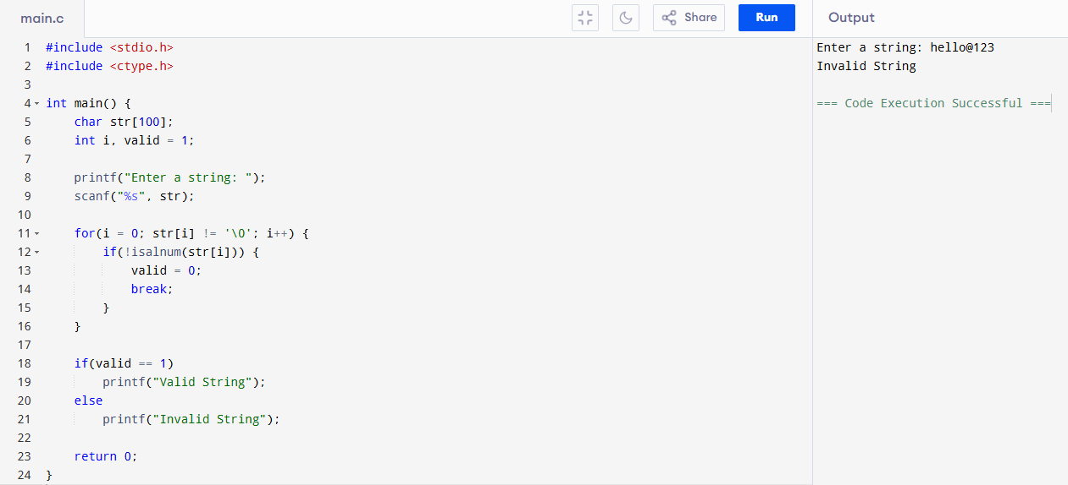

EX.NO:30 LINEAR SEARCH FOR STUDENT REGISTER NUMBER
#include <stdio.h>
int main() {
int reg[100], n, key, i, found = 0;
printf("Enter number of students: ");
scanf("%d", &n);
printf("Enter %d registration numbers:\n", n);
for(i = 0; i < n; i++) {
scanf("%d", &reg[i]);
}
printf("Enter registration number to search: ");
scanf("%d", &key);
for(i = 0; i < n; i++) {
if(reg[i] == key) {
found = 1;
break;
}
}
if(found == 1)
printf("Registration number found at position %d\n", i + 1);
else
printf("Registration number not found\n");
return 0;
}
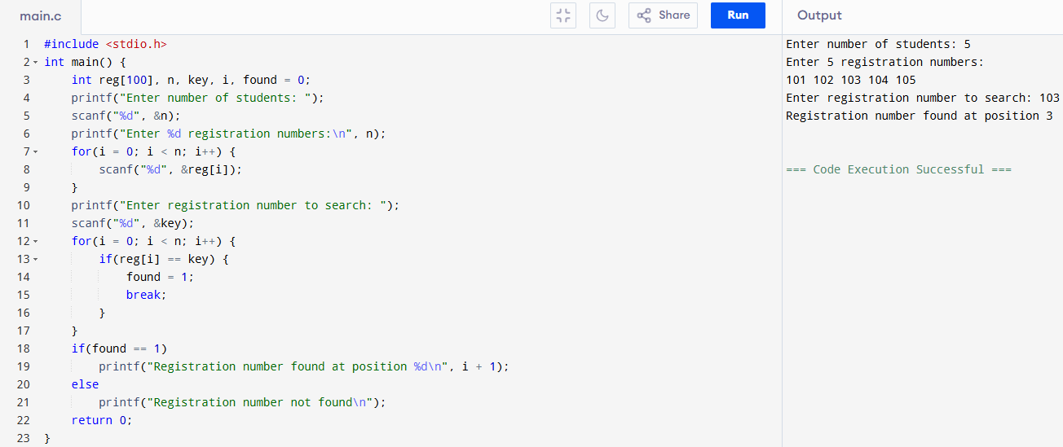
EX.NO:31 BINARY SEARCH FOR STUDENT REGISTER NUMBER
#include <stdio.h>
int main() {
int reg[100], n, key, low, high, mid, found = 0, i;
printf("Enter number of students: ");
scanf("%d", &n);
printf("Enter %d registration numbers (in sorted order):\n", n);
for(i = 0; i < n; i++)
scanf("%d", &reg[i]);
printf("Enter registration number to search: ");
scanf("%d", &key);
low = 0;
high = n - 1;
while(low <= high) {
mid = (low + high) / 2;
if(reg[mid] == key) {
found = 1;
break;
}
else if(key < reg[mid])
high = mid - 1;
else
low = mid + 1;
}
if(found == 1)
printf("Registration number found at position %d\n", mid + 1);
else
printf("Registration number not found\n");
return 0;
}
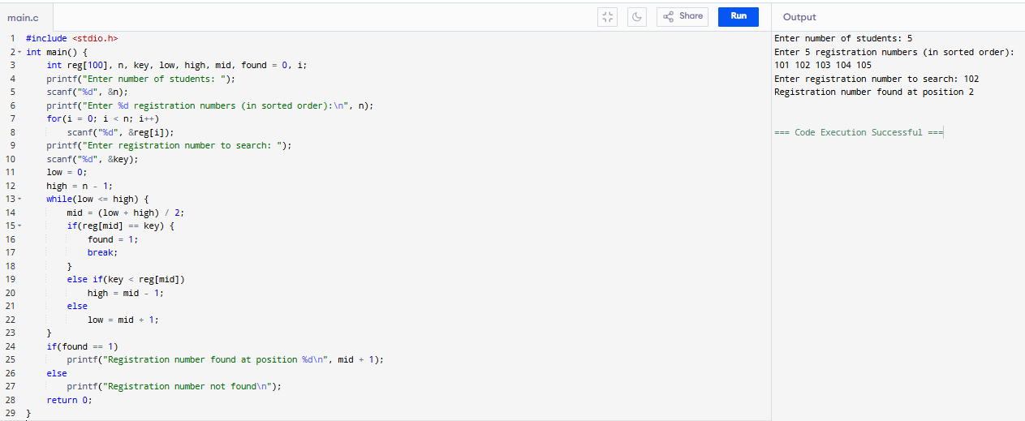

EX.NO:32 IDENTIFY LOCATION OF ELEMENT IN GIVEN ARRAY
#include <stdio.h>
int main() {
int a[50], n, key, i, found = 0;
printf("Enter number of elements: ");
scanf("%d", &n);
printf("Enter %d elements:\n", n);
for(i = 0; i < n; i++)
scanf("%d", &a[i]);
printf("Enter element to find: ");
scanf("%d", &key);
for(i = 0; i < n; i++) {
if(a[i] == key) {
printf("Element found at position %d\n", i + 1);
found = 1;
break;
}
}
if(!found)
printf("Element not found\n");
return 0;
}
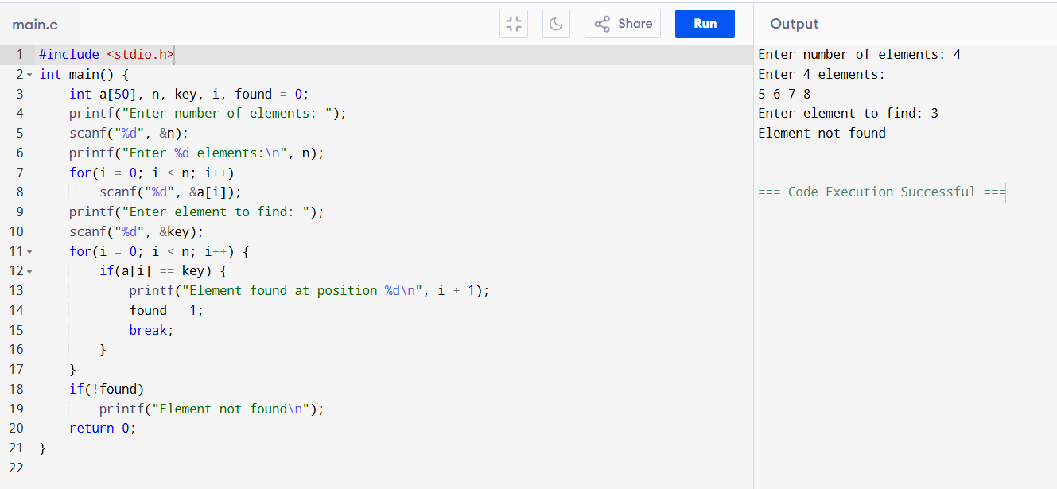
EX.NO:33 TO PRINT ODD AND EVEN VALUES
#include <stdio.h>
int main() {
int a[50], n, i;
printf("Enter number of elements: ");
scanf("%d", &n);
printf("Enter %d elements:\n", n);
for(i = 0; i < n; i++)
scanf("%d", &a[i]);
printf("\nEven numbers: ");
for(i = 0; i < n; i++) {
if(a[i] % 2 == 0)
printf("%d ", a[i]);
}
printf("\nOdd numbers: ");
for(i = 0; i < n; i++) {
if(a[i] % 2 != 0)
printf("%d ", a[i]);
}
return 0;
}
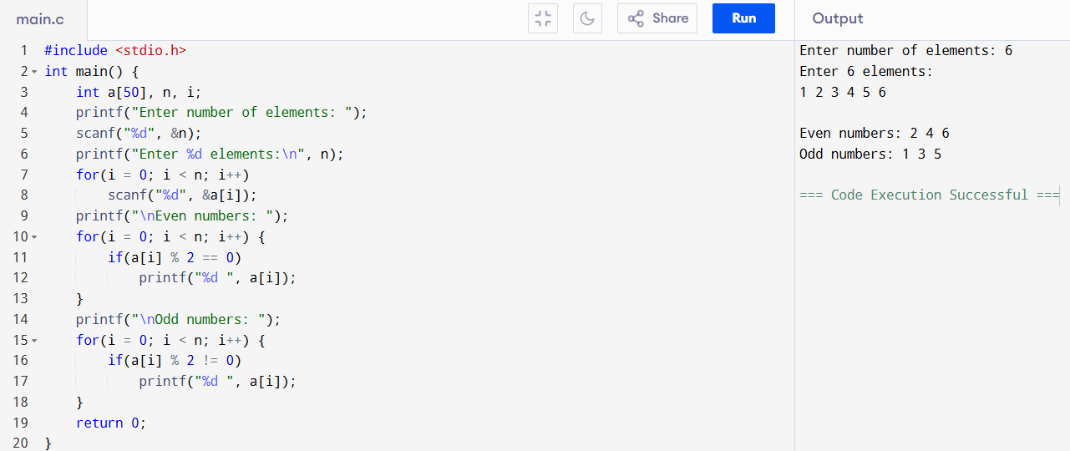
EX.NO:34 SUM OF FIBONACCI SERIES
#include <stdio.h>
int main() {
int n, a = 0, b = 1, c, i, sum = 0;
printf("Enter number of terms: ");
scanf("%d", &n);
printf("Fibonacci Series: ");
for(i = 1; i <= n; i++) {
printf("%d ", a);
sum += a;
c = a + b;
a = b;
b = c;
}
printf("\nSum of Fibonacci Series = %d\n", sum);
return 0;
}
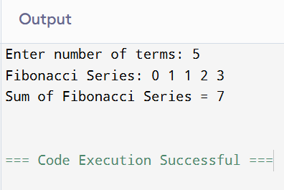
EX.NO:35 FINDING FACTORIAL OF A NUMBER
#include <stdio.h>
int main() {
int n, i;
long long fact = 1; // to handle large numbers
printf("Enter a number: ");
scanf("%d", &n);
if (n < 0)
printf("Factorial of negative number is not possible.\n");
else {
for (i = 1; i <= n; i++) {
fact = fact * i;
}
printf("Factorial of %d = %lld\n", n, fact);
}
return 0;
}
